Cathkin High School

English Department

S1 Reading and Language Support Booklet

This booklet belongs to

____________________



Booklet 1

**Golf**

Golf is a sport in which a player, using a variety of different clubs, hits a ball into each hole on a golf course in the lowest possible number of strokes. Golf is one of the few ball games that does not use a standard sized playing area, rather the game is played on “courses”, each one of which has a unique design and typically consists of nine or eighteen holes.

The first game of golf for which records exist was played at Bruntsfield Links in Edinburgh, Scotland in 1456. The modern game has spread from Scotland and is now played in most countries in the world.

Golf competition may be played as stroke play, in which an individual with the lowest score is declared the winner or as matchplay.

Golf has now become a major spectator sport and players are well recognised as celebrities. Sponsorship has also become part of the game where players are paid large amounts amount of money to wear or use a particular brand.

**Questions**

1. What is used to play golf?

 2. How is the winner of the game decided?

 3. What is unusual about where golf is played?

 4. What do you call the area on which the game is played?

 5. How many holes are there on a typical course?

 6. When and where did the first recorded game take place?

 7. What are the two ways in which the game can be scored?

 8. What is meant by ‘spectator sport’?

 9. What does the word ‘celebrities’ tell you?

10. Why do some players get sponsored?

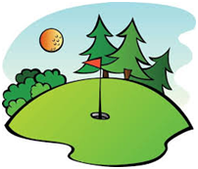



**Conjunctions**

A conjunction is a word that links words, phrases, or clauses.

For example: And, or, but, nor, so, for, yet, as, wherever, while, that, until, what, when, since, because.

Task

Look at the sentences below. Turn each example into ONE

sentence using a conjunction.

1 The scarf was very expensive. It had been woven by hand.

2 The play went ahead. The leading actor was not well.

3 He wanted to go in swimming with his friends. He had forgotten his swimming trunks.

4 The roof needed seven new tiles. They had been blown off in the storm.

**Going Solo**

But our luck held, and after two more weeks at sea, on a black wet night in early autumn, we nosed our way into Liverpool Docks and tied up. I ran down the gangway immediately and went off to try and find a telephone kiosk that had not been bombed out of action. When I found one at last, I was literally shaking with excitement at the thought of speaking to my mother again after three years. She could not possibly have known that I was on my way home. The censor would not have allowed such things to be written in letters, and I myself had not heard from anyone in the family for many months. No letter from England had found its way up to Haifa. I got the trunk-call operator and asked for our old number in Kent. After a pause, she told me it had been disconnected months ago. I asked her to consult Directory Inquiries. No, she said, there were no Dahls in Bexley or anywhere else in Kent come to that.

The operator sounded like a lovely elderly lady. I told her how I had been abroad for three years and was trying to find my mother. "She’ll have moved.", the operator said. "She’ll probably have been bombed out like all the rest of them and she’s had to move somewhere else." She was too kind to add that the whole family might well have been killed in the bombing, but I knew what she was thinking and she probably guessed that I was thinking it, too.

(From *Going Solo* by Roald Dahl)

**Questions**

1. When does the ship arrive at the docks?

 2. What does Dahl immediately do?

 3. Which phrase describes how he felt about speaking to his mother?

 4. How long had it been since he last spoke to her?

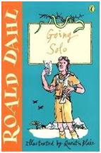 5. What could his mother not possibly have known?

 6. What was part of the ‘censor’s’ job?

 7. Where is Bexley situated?

 8. Write down an adjective used to describe the operator.

9. What does the operator suggest has happened to his family?

 10. What does Dahl think the operator is too kind to say?

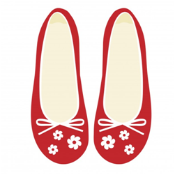**The Lollipop Shoes**

That finally decided it. That night I packed for a one-way journey. I took her passport and my own; some clothes; some money; her credit cards; cheque-book and keys to the shop. Call me sentimental; I also took one of her earrings – a little pair of shoes – as a charm to add to my bracelet. I’ve added to it a lot since then. Every charm here is a trophy of sorts, a reminder of the many lives I have collected and used to enrich my own. But that’s where it really started. With a single pair of silver shoes.

Then I crept softly downstairs, lit a couple of fireworks I’d bought that day and dropped them among the stacks of books before very quietly letting myself out.

I never looked back. There was no need. My mother always slept like the dead, and besides, the dose of valerian and wild lettuce that I’d slipped in her tea would surely have quietened the most restless of sleepers. Scott and his friends would be suspects at first – at least until my disappearance was confirmed – by which time I fully intended to be over the seas and far away.

(From *The Lollipop Shoes* by Joanne Harris)

**Questions**

1. In your own words, what does a ‘one-way’ journey mean?

 2. List four of the items she takes with her.

 3. Explain what you think ‘sentimental’ means.

 4. What does she do with the one earring?

 5. Which word describes each charm she has?

 6. Which adverb describes how she moves down the stairs? 

 7. What does she do before letting herself out?

 8. Which simile describes how her mother sleeps?

 9. Name the two items used to make sure her mother is asleep.

 10. Who does she think will be the initial suspects?

**Word Classes**

Over the next few pages you will be looking at different types of words. Words fit into certain classes.

Nounsare naming words. For example: desk, chair, wall, table.

Pronouns are words we use in place of nouns.

For example: he, she, it, them.

Adjectivesare describing words. For example: tall, thin, round, small.

Verbsare doing words. For example: walk, throw, drink, eat.

Adverbsare words which describe the verb.

For example: quickly, secretly, soon.

Prepositionsare words which show a relationship between

things. For example: on, under.

Conjunctionsare joining words. For example: and, but, when.

**If we understand to which class a word belongs, it may help us understand its meaning or context.**

**NOUNS**

A noun is a naming word. There are FOUR different types of noun in English:

A common noun is a word which names something.

For example: table, pen, girl, cat, computer, trousers, ticket.

A proper noun is a word which refers to a particular place, person or thing.

For example: Cathkin, Scotland, William Shakespeare, University of Glasgow.

An abstract noun is a word which describes something we cannot see, hear, or touch.

For example: fear, justice, truth, curiosity, relaxation, bravery.

A collective noun is a word which describes a group of people, animals or objects as a group.

For example: a flock of birds, a range of mountains, a team of players.

**[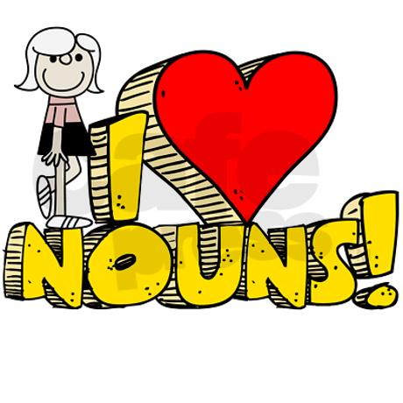](http://www.google.co.uk/url?sa=i&rct=j&q=nouns&source=images&cd=&cad=rja&uact=8&ved=0CAcQjRw&url=http://tx.english-ch.com/teacher/julia/level-a/nouns/&ei=g5f9VKTeLsqxUbCpgpgC&psig=AFQjCNHTiuJmlTZYabjRSPYtbZI8ymeXlw&ust=1425991894057751)**

**PRONOUNS**

Pronouns are not nouns: they are words we use instead of nouns.

For example:

I, me, we, us, he, she, him, her, it, they, them, ours, yours.

TASK

Fill in the correct type of word below.

The word “anger” is an .

The word “shoe” is a .

The word “his” is a .

[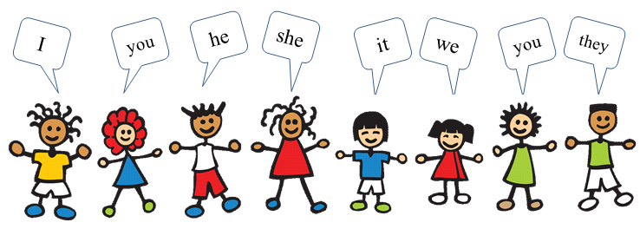](http://www.google.co.uk/url?sa=i&rct=j&q=pronouns&source=images&cd=&cad=rja&uact=8&ved=0CAcQjRw&url=http://www.englishexercises.org/makeagame/viewgame.asp?id=9611&ei=6pn9VLSzI8n-UoOwg4gE&psig=AFQjCNHTU17Ee8wJ3LX5-ERDbLpssMEmgw&ust=1425992522400262)

**Collective Nouns**

Fill in the blank spaces using words from the box below.

1 A of cows.

2 A of pupils.

3 A of fish.

4 A of bees.

5 A of soldiers.

6 An of ravens.

7 A of ships.

8 A of bananas.

**Fleet Herd Platoon Unkindness**

**Hand Shoal Class Swarm**

[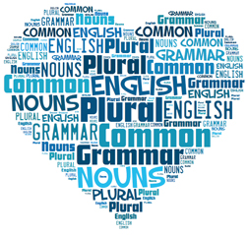](http://www.google.co.uk/url?sa=i&rct=j&q=nouns&source=images&cd=&cad=rja&uact=8&ved=0CAcQjRw&url=http://www.lousywriter.com/nouns-plural-of-common-nouns.php&ei=YZf9VJeNJYLkUa7Bg-AK&psig=AFQjCNHTiuJmlTZYabjRSPYtbZI8ymeXlw&ust=1425991894057751)

**Pronouns**

A pronoun is a word that we use instead of a noun. We use pronouns to make our sentences less repetitive and easier to read.

For example:

“Mark picked up Mark’s gamepad and Mark began to press the buttons on the gamepad.” becomes “He picked up his gamepad and he began to press the buttons on it.”

Look at the sentences below. Re-write the sentences on the line below and try to change SOME of the NOUNS to PRONOUNS. (You don’t have to change all of the nouns.)

1 Kerry stared thoughtfully out of the window.

2 Mark was looking forward to playing football after school.

3 It was a hot day and Katy wanted an ice-cream. When Katy bought the ice-cream Katy enjoyed the ice-cream.

4 Craig put the ball down. Craig kicked the ball into the goals.

5 John could not think of anything to say. John had seen Martin talking but John did not want to say anything.

**Follow this guide and complete in your jotter for the letters assigned to you each week.**

**Simile and Metaphor**

[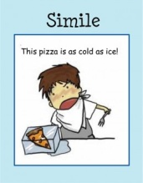](http://www.google.co.uk/url?sa=i&rct=j&q=simile&source=images&cd=&cad=rja&uact=8&ved=0CAcQjRw&url=http://jackson13.wikis.birmingham.k12.mi.us/Simile+and+metaphor+BrettAerik4&ei=qQf_VKzWBdDoaL2KgLAO&psig=AFQjCNGFz3yGJr43LUwRDxsMe__jTGEROg&ust=1426086181287697)

A simile is where two things are directly compared because they share a common feature. The word AS or LIKE is used to compare the two words. For example, “It is as cold as ice in here!”

A metaphor also compares two things, but it does so more directly without using as or like. For example, “I do not like Iain, he is a pig.”

**Look at the examples below and write under them whether they are a simile or a metaphor.**

1. His hand was as cold as ice.
2. She gave him an icy glare.

____

1. My love is like a red, red rose.
2. It is the East and Juliet is the sun.

1. As idle as a painted ship upon a painted ocean.

1. Music is the food of love.

1. He was as strong as Hercules.
2. His gaze was like fire.

**[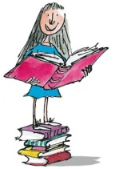](http://www.google.co.uk/url?sa=i&rct=j&q=matilda+quentin+blake&source=images&cd=&cad=rja&uact=8&ved=0CAcQjRw&url=http://www.london24.com/news/new_years_honours_quentin_blake_knighted_1_1755601&ei=Rpb9VNOPEMqtU9a_gZgI&psig=AFQjCNElPHXBETyIkrnrJO-s3CnL9HaIYw&ust=1425991618259697)Matilda**

Now most head teachers are chosen because they possess a number of fine qualities. They understand children and they have the children’s best interests at heart. They are sympathetic. They are fair and they are deeply interested in education. Miss Trunchbull possessed none of these qualities and how she ever got her present job was a mystery.

She was above all a most formidable female. She had once been a famous athlete, and even now the muscles were still clearly in evidence. You could see them in the bull-neck, in the big shoulders, in the thick arms, in the sinewy wrists and in the powerful legs. Looking at her, you got the feeling that this was someone who could bend iron bars and tear telephone directories in half. Her face, I’m afraid, was neither a thing of beauty nor a joy for ever. She had an obstinate chin, a cruel mouth and small arrogant eyes. And as for her clothes …they were, to say the least, extremely odd. She always had on a brown cotton smock which was pinched in around the waist with a wide leather belt. The belt was fastened in front with an enormous silver buckle. The massive thighs which emerged from out of the smock were encased in a pair of extraordinary breeches, bottle green in colour and made of coarse twill.

**Questions**

1. Name two qualities possessed by most head teachers.

2. What do you think the word ‘sympathetic’ means?

 3. Which word describes how Trunchbull got the job?

 4. What do you think the word ‘formidable’ means?

 5. What was Trunchbull before she became a head teacher?

 6. Name two places where Trunchbull’s muscles can be seen.

 7. Choose your own word to describe Trunchbull’s face.

 8. Which adjective describes Trunchbull’s mouth?

 9. Describe what Trunchbull is wearing.

 10. What do you think her ‘breeches’ are?

Budding author?

C:\Users\lnichol\Local Settings\Temporary Internet Files\Content.IE5\F68WUEGP\MC900413460[1].wmf

Try this…

Choose one of these beginnings of a story and see where your imagination takes you. Try to write the rest of the story. Remember to try hard to write in detail, making settings, characters and the plot of the story detailed, descriptive and interesting.

1. In the morning, Jenna knew she had made a big mistake.
2. Sean and Allan were in the station waiting for their train after football.
3. The beach was deserted, calm and peaceful.
4. Dishes smashed on the floor as the boat was hit by a huge wave.
5. Martin had just sat down on the bus when he remembered his Maths homework…
6. The garden seemed totally different in the dark…kind of shadowy and spooky.

[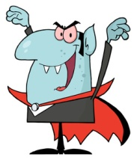](http://www.google.co.uk/url?sa=i&rct=j&q=vampire+for+kids&source=images&cd=&ved=0CAcQjRw&url=http://www.clipartpanda.com/categories/vampire-clip-art-for-kids&ei=oJb9VKujFIavUdC5gbAG&psig=AFQjCNHUyyGRprvMdpIfNCdrboAS06qZsA&ust=1425991704587507)**The Vampyre**

Above her loomed a mansion-front. Its grandeur seemed quite out of proportion to the alley, otherwise narrow and blank, in which Rebecca found herself. In the moonlight the stone of the mansion was cast maggot-white; its windows were pools of darkness, sockets in a skull; the impression given by the whole was that of something quite abandoned by time, a shiver of the past conjured up by the moon. The wind began to scream again. Rebecca watched as the light faded, then was lost. The mansion, though, remained revealed now as something more than just an illusion of the moon, but Rebecca was not surprised; she had known full well that it was real; she had called at these mansion gates before.

She did not bother this time, however, to climb the steps and knock at the door. Instead she began to walk down the mansion-front, past the railings that speared up from the pavement, guarding the mansion from the passer-by. Rebecca could smell the acid again, just faint on the wind, but bitter as before. She began to run. There were footsteps behind her. She glanced round, but there was nothing, and she felt the terror return, descending on her like a poisonous cloud, choking her throat, burning her blood. (From *The Vampyre* by Tom Holland)

**Questions**

1. Describe what you think a ‘mansion’ is.

 2. Which metaphor describes the colour of the stone?

 3. Choose a metaphor to describe the mansion’s windows.

 4. What do you think the phrase ‘abandoned by time’ means?

 5. Choose the example of personification which describes the wind.

 6. What do you think the word ‘illusion’ means?

 7. How do we know this is not Rebecca’s first visit?

8. What does Rebecca not bother to do this time?

 9. What are the railings used to guard against?

 10. Which simile describes the terror Rebecca feels?

**Verbs**

A verb is a word, or a group of words that tells us what a person or thing is doing or being. Verbs are sometimes called “doing words”.

For example: run, talk, write, swing, bite, take, found, see, learn, practise, read.

Read the sentences below and fill in the missing verb.

1 Tommy to the town centre.

2 Joanne the cake at her birthday party.

3 The wind was so strong that the trees down.

4 She asked him if he would like to to her party on Saturday.

5 “Can you me the time please?”

6 I am going to school uniform today.

7 “Can you tell me how to your name please?”

8  “I am bored with my Playstation and I am going to it.”

He said

9 It is important that you do not school rules.

10 It is important that you try to properly.

[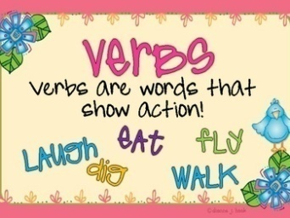](http://www.google.co.uk/url?sa=i&rct=j&q=verbs+for+kids&source=images&cd=&cad=rja&uact=8&ved=0CAcQjRw&url=http://englishnart4fun.blogspot.com/2014/04/grammar-past-perfect.html&ei=epn9VPPSEMj3UNrzg4gB&psig=AFQjCNH6L_4ptk6hgDh8xf7NlKjF4tneRQ&ust=1425992434816738)

**[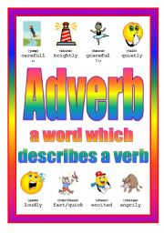](http://www.google.co.uk/url?sa=i&rct=j&q=adverb&source=images&cd=&cad=rja&uact=8&ved=0CAcQjRw&url=http://www.eslprintables.com/teaching_resources/posters/Adverb_Poster_4th_of_4_107541/&ei=opj9VPPXIcLZU5uLg8gC&psig=AFQjCNEtiUOq0swWIRpg_GHh3cTXqChpkg&ust=1425992199986184)**

**Adverbs**

An adverb is a word which tells us more about words which are not nouns. Adverbs usually help with questions such as *how?" (or "in what way?*), *when?*, *where?*, *why?* and *to what extent?*. In English, they often end in *-ly*.

For example: quickly, punctually, suddenly, defiantly, sometimes, yesterday, only, less, very.

Look at the sentences below and try to fill in an appropriate adverb.

1 He smiled at the camera.

2 Jason ran into the room.

3 She said, “I am going to put the box .”

4 Daniel had not seen Graeme that day. “I saw him .” he said.

5 I get a sore head in the morning.

6 Jenna jumped down the stairs and out of the house.

8 Craig’s tooth began to throb again.

9 Siobhan crept out of where she had been hiding.

10 Andrew shouted on everyone to pay attention to him.

**[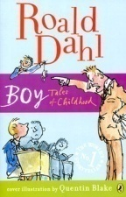](http://www.google.co.uk/url?sa=i&rct=j&q=roald+dahl+boy&source=images&cd=&ved=0CAcQjRw&url=http://www.goodreads.com/book/show/6667.Boy&ei=3Zb9VNOIHYPtUrqvgfgP&psig=AFQjCNHlrFDtATn9TQXcTYe1utqiJS3mOw&ust=1425991769438718) Boy**

Spurred on by our shouts and taunts, the ancient sister began to increase the speed. The engine roared and the body vibrated. The driver was clutching the steering wheel as though it were the hair of a drowning man, and we all watched the speedometer needle creeping up to twenty, then twenty-five, then thirty. We were probably doing about thirty-five miles an hour when we came suddenly to a sharpish bend in the road. The ancient sister, never having been faced with a situation like this before, shouted ‘Help!’ and slammed on the brakes and swung the wheel wildly round. The rear wheels locked and went into a fierce skid, and then, with a marvellous crunch of mudguards and metal, we went crashing into the hedge. The front passengers all shot through the front windscreen and the back passengers all shot through the back windscreen. Glass (there was no Triplex then) flew in all directions and so did we. My brother and one sister landed on the bonnet of the car, someone else was catapulted out on to the road and at least one small sister landed in the middle of the hawthorn hedge. But miraculously nobody was hurt very much except me. My nose had been cut almost clean off my face as I went through the rear windscreen and now it was hanging on only by a single small thread of skin. My mother disentangled herself from the scrimmage and grabbed a handkerchief from her purse. She clapped the dangling nose back into place fast and held it there. (From *Boy* by Roald Dahl)

**Questions**

1. Explain in your own words what ‘spurred on’ means.

 2. ‘The engine roared’ is an example of what type of figure of speech?

 3. Which metaphor describes how the driver clutched the steering wheel?

 4. How fast were they going at the bend?

 5. What does the ancient sister do?

 6. What do they all crash through?

 7. What happens to the back passengers?

 8. Where does one small sister end up?

9. What happens to the narrator’s nose?

 10. Choose one example of onomatopoeia from the passage.

**Prepositions**

A preposition is a word which links nouns, pronouns and phrases to other words in a sentence. The word or phrase that the preposition introduces is called the object of the preposition.

For example: on, over, beneath, beside, between, across, except, in, from, of, like, during, with.

Task

Look at the sentences below and underline all of the prepositions that you can find.

1 Alison was looking for her book under the table but she could not see that it was really on the high shelf above her head.

2 It was during the night and Brian could not sleep. He was inside his sleeping bag which was beside a big tree. From the woods beyond the campsite he could hear some eerie noises.

3 Caitlin ran after the bus but it was too late – she had already missed it. She could see her friend among the other people looking through the window. Caitlin was sure that she would hear about it throughout the day.

4 Between the two goalposts, Gregory stood freezing. He had been up since six in the morning, practising his saves on the pitch. He wasn’t going to go back inside the building until he was a lot better.

[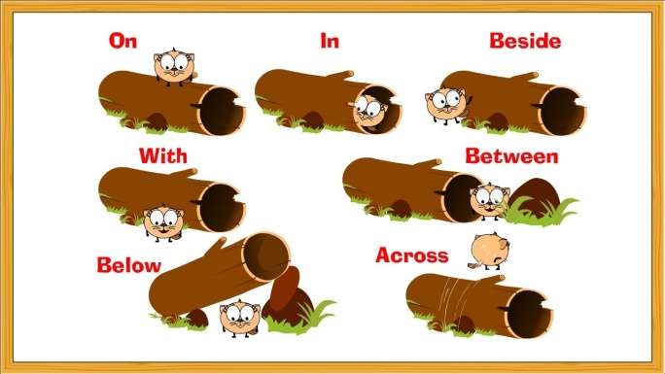](http://www.google.co.uk/url?sa=i&rct=j&q=preposition&source=images&cd=&cad=rja&uact=8&ved=0CAcQjRw&url=http://www.youtube.com/watch?v=GKGVEQ-14t0&ei=4Jj9VOHzFsToUtaLgJAE&psig=AFQjCNFm3fA611OTUL6RYzjd-7z19c4sLw&ust=1425992274789224)

**Disney Word Search**

|  |  |  |  |  |  |  |  |  |  |  |  |  |  |  |  |  |  |  |  |  |  |  |  |
| --- | --- | --- | --- | --- | --- | --- | --- | --- | --- | --- | --- | --- | --- | --- | --- | --- | --- | --- | --- | --- | --- | --- | --- |
| e | d | l | c | d | q | p | m | a | r | t | e | h | t | d | n | a | y | d | a | l | e | s | h |
| t | k | q | w | n | v | f | b | t | t | l | y | k | c | b | n | r | k | l | n | n | d | n | l |
| i | a | x | h | g | t | n | k | m | i | q | g | g | x | x | h | g | i | t | o | g | l | a | l |
| h | r | x | m | z | x | h | f | o | z | n | l | y | v | g | n | l | k | t | b | t | v | i | f |
| w | i | l | f | n | r | h | n | m | q | z | m | l | g | g | o | x | s | t | f | p | w | t | d |
| w | s | d | i | h | m | k | e | n | y | v | c | q | t | a | r | e | x | h | p | n | m | a | n |
| o | t | k | l | t | i | d | r | r | l | n | r | r | n | r | h | n | s | l | b | x | n | m | a |
| n | o | b | h | n | t | m | t | t | c | r | r | d | v | t | b | r | x | j | a | k | n | l | l |
| s | c | c | g | p | v | l | w | m | g | u | s | p | n | m | e | y | y | t | m | j | b | a | r |
| m | a | n | k | t | f | g | e | c | t | t | l | i | l | u | w | k | k | p | b | v | r | d | e |
| r | t | t | r | l | p | r | l | m | i | k | d | e | c | y | l | w | l | z | i | j | h | e | d |
| e | s | m | n | c | j | b | p | t | e | r | t | s | s | n | x | m | n | l | c | n | q | n | n |
| n | l | r | t | k | l | h | c | l | o | r | e | j | u | n | g | l | e | b | o | o | k | o | o |
| p | r | t | r | m | p | h | l | w | n | r | m | b | f | m | k | c | v | m | x | v | m | d | w |
| f | r | j | t | j | b | k | s | k | e | l | r | a | b | b | d | p | w | w | l | k | w | n | n |
| m | y | v | c | i | n | t | h | h | r | t | d | r | i | b | k | v | f | k | l | x | p | a | i |
| v | g | z | b | h | l | p | t | t | k | l | r | n | b | d | g | t | t | b | f | r | q | d | e |
| q | b | r | m | f | r | n | d | g | p | l | t | d | j | x | d | l | r | v | r | z | n | e | c |
| r | q | t | n | n | m | b | e | v | k | w | d | o | o | h | n | i | b | o | r | c | t | r | i |
| b | k | j | p | j | r | w | j | k | p | i | n | o | c | c | h | i | o | m | t | q | p | d | l |
| n | x | h | q | c | m | w | x | h | c | p | x | z | r | n | r | j | d | v | t | h | w | n | a |
| y | f | d | t | r | g | l | p | t | k | i | b | n | k | f | k | t | n | n | k | t | l | u | y |
| r | m | t | c | m | x | n | g | l | n | j | h | r | g | t | t | m | m | q | z | y | c | h | z |
| b | g | w | l | w | f | l | n | t | r | j | k | c | x | z | r | t | k | l | q | t | g | a | x |

**Just for fun!**

 Alice in Wonderland Aristocats Lilo and Stitch

A hundred and one Dalmations Bambi Lion King

Little Mermaid Chicken Little Jungle Book

Hercules The Rescuers Lady and the Tramp

Sword in the Stone Snow White